**Core Functionalities**

Core functionality is something which is the most important or necessary part of a website on which website is fully dependent.

**For example:** We cannot type text without touchpad in android mobile. So touchpad became core function for android mobile.

Here process cycle shown below for core functionalities of website:

**Figure A: Process Cycle having 6 core functionalities**

Let’s talk about core functionalities for Reaction Commerce which are shown below:

1. **Dashboard:** Dashboard is known as Brain of the system through which we can view overall process and status of customers with their details and latest updates which is correlated to customers.

Dashboard includes Status of activities, Account managements, Notifications, Orders, Payments, Shipping details for customers.

**For Example**: Customer ordered a product from the website but somehow product has not been delivered to customer. So admins can track customer’s information through dashboard and their shipping details and status activities along with notes and notification to resolve the issues.

Dashboard image is shown below to demonstrate how dashboard looks like for our project:

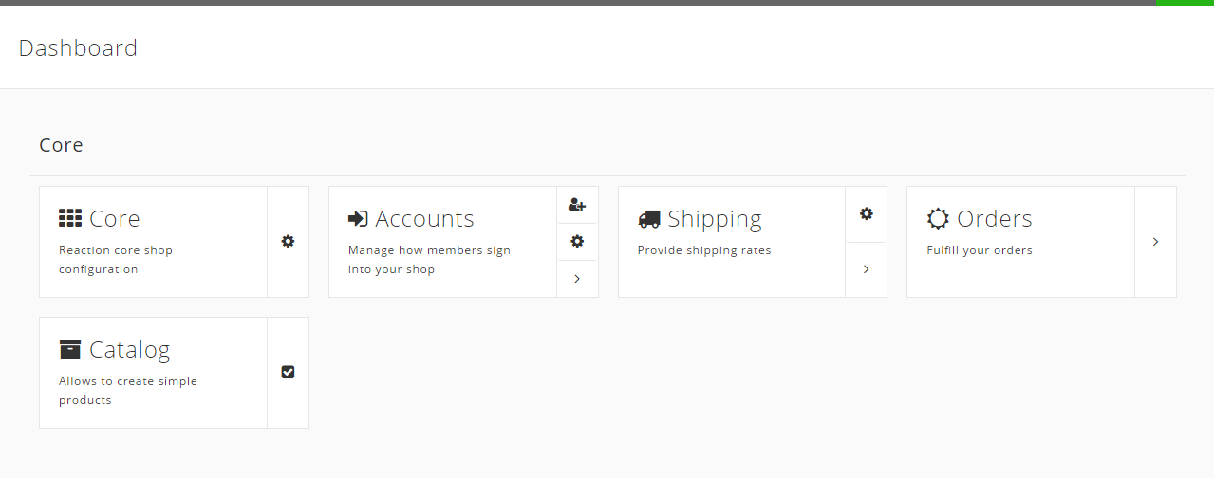

**Figure 1.1: Core feature for Dashboard**

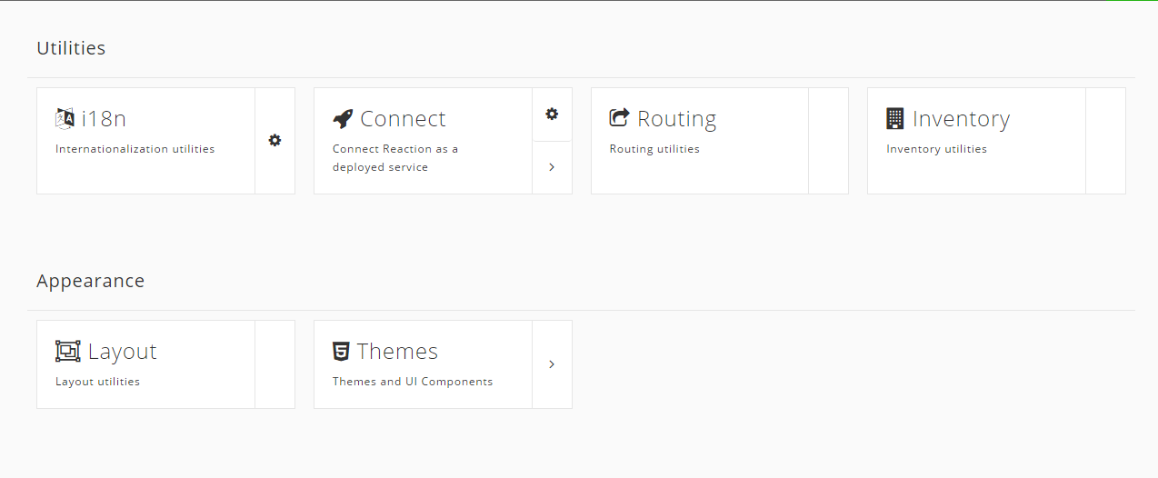

**Figure 1.2: Utility feature for Dashboard**

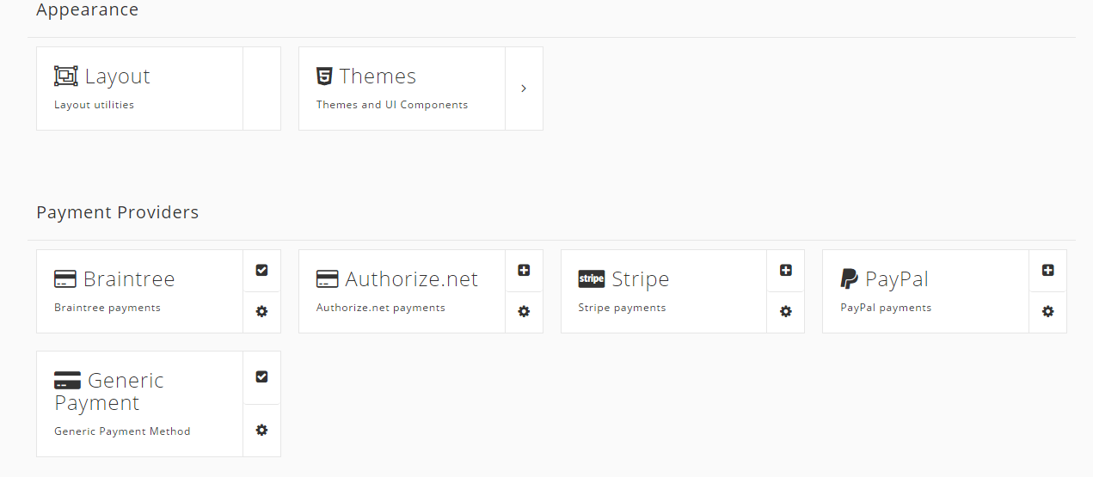

**Figure 1.3: Appearance and Payment Features for Dashboard**

1. **Account Management:** Accounts Management is all about managing complete Customer details. Admins can manage all customer details for easier deal with customers.

It can includes Name, Full address, Billing address, Shipping address, Shipping status, history of particular customers, Payment status, etc.

In short it is having all details which is necessary to have to keep track of customers to maintain good relationship for business.

**For Example:** To send promotional offers to some customers via Email and Currier or Post. Email address and full address is necessary to have. We can get those stuff from account management in customer details.

Account Management figure is shown below to demonstrate how it looks like for our project:

**Figure 2.1: Shop members and manage features for Account Management Function**

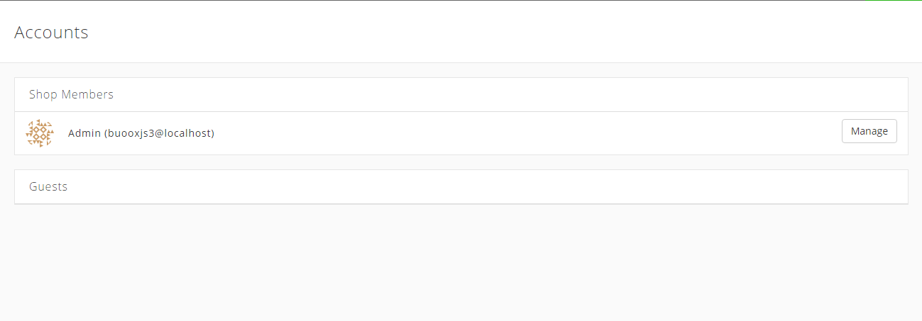

1. **Product Management:** Product management is the major part of the main stream business. In product management, you can create and edit items or products in reaction shop- through which viewers can view the products. Just as Dashboard is called the brain of Reaction Commerce, the Product Management is called the heart of Reaction shop.

It includes features such as editing products, removing products, add to cart, Prices, etc. New products can be created in reaction shop. It is very easy to manage.

**For Example:** New product has come and need to put on website. Product Management tag will help you to create new product, add description and details of product, allows you to insert product image as well. Admins will able to manage products easily.

Illustration has shown below in the form of snapshot of Product management for our project:

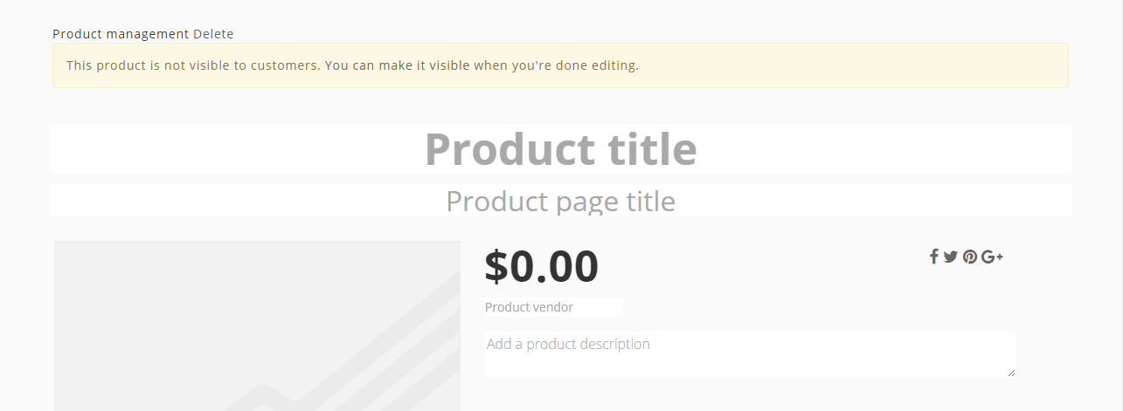

**Figure 3.1: Product price, Edit and upload image features for Product Management Function**

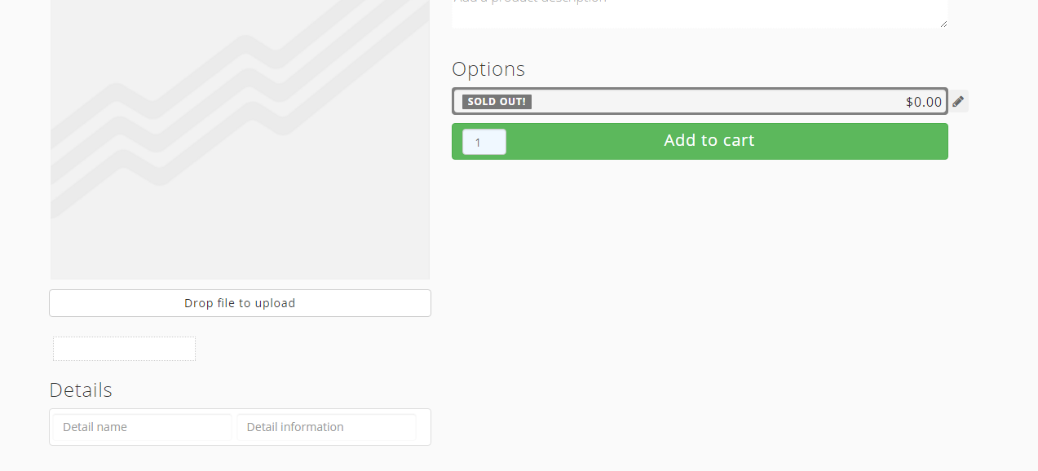

**Figure 3.2: Add to cart, Product Description or details features for Product Management Function**

1. **Orders:** Order processing is the stage through which the administrator can log in and view the orders, by selecting the order icon from the menu of the website. The first stage of reaction commerce that is, Dashboard has the sub stage of Order Processing, and through this also we can access the orders placed.

Admins able to manage several orders by viewing. It includes new orders placed, Orders are under process or processing, Orders completed. In short admins come to know status of orders.

**For Example:** If customer ordered product from website. So admins can manage order process for the customers and can send alerts or updates to customer about their product orders.

Snapshot shown below which gives some idea how orders tab looks like for our project:

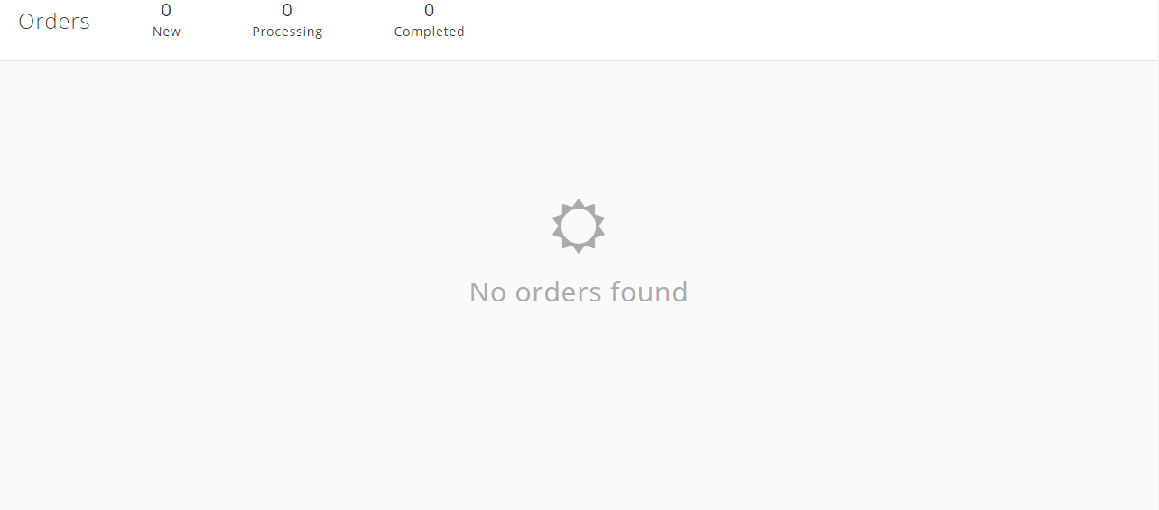

**Figure 4.1: Order Processing snapshot**

1. **Payment Management:** Through Payment management, admins can manage payments done by customers or payments remaining by customers.

It includes, Payment completed, Payment remaining, payment history, late payment and upcoming payments, etc.

There are several Payment providers can be associated with website such as Paypal, Authorize.net. Brainee, Stripe, etc.

**For Example:** Customer ordered computer peripherals from website and made payment through credit card. So payment will be processed and it will show status of payment into payment management category or into Dashboard in the form of alert.

Here is the snapshot shown below indicated payment management page for our project:

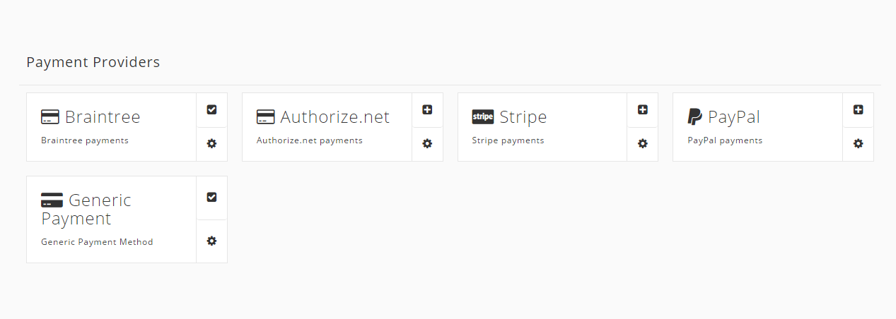

**Figure 5.1: Payment providers are linked to this website for better payment process.**

1. **Shipping:** We can navigate shipping by logging in to the website. Once logged in we can edit the shipping rules or add the same. Admins able to see shipping history as well as can track the order placed by customers.

According to a website, reaction has three basic flat rate shipping rules; Free, Standard and Priority. Each of these flat shipping rate rules can be taken in to consideration according to the orders placed.

**For example:** some of the websites have shipping charge not included in the product price and they charge it separately, while the same product on other website has no shipping charge included in it. So it depends on the website and the kind of order placed by the customer.

Here is snapshot shown below indicates shipping page for the project.

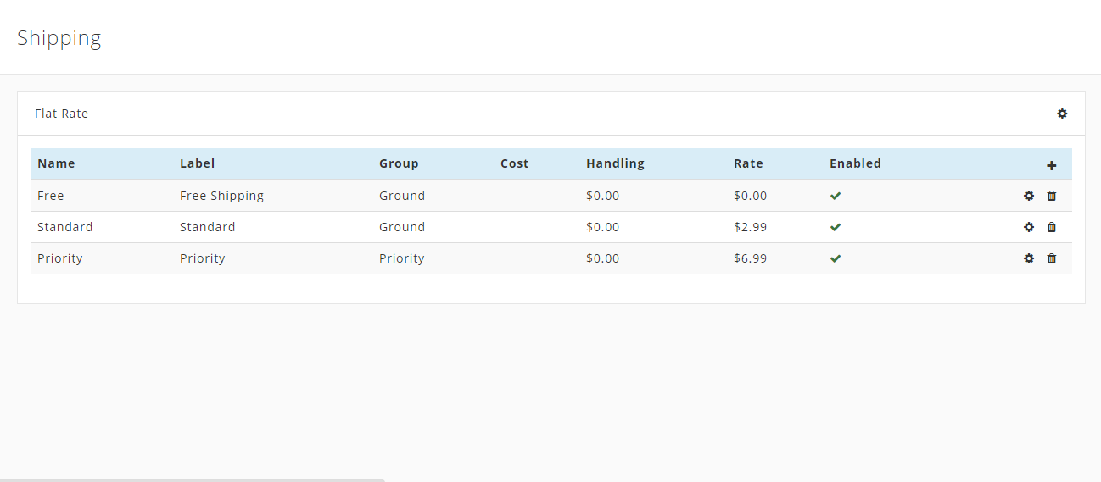

**Figure 6.1: Contains the categories for shipping and how to manage them.**

**References**

<https://docs.reactioncommerce.com/>

<https://reactioncommerce.com/features/>